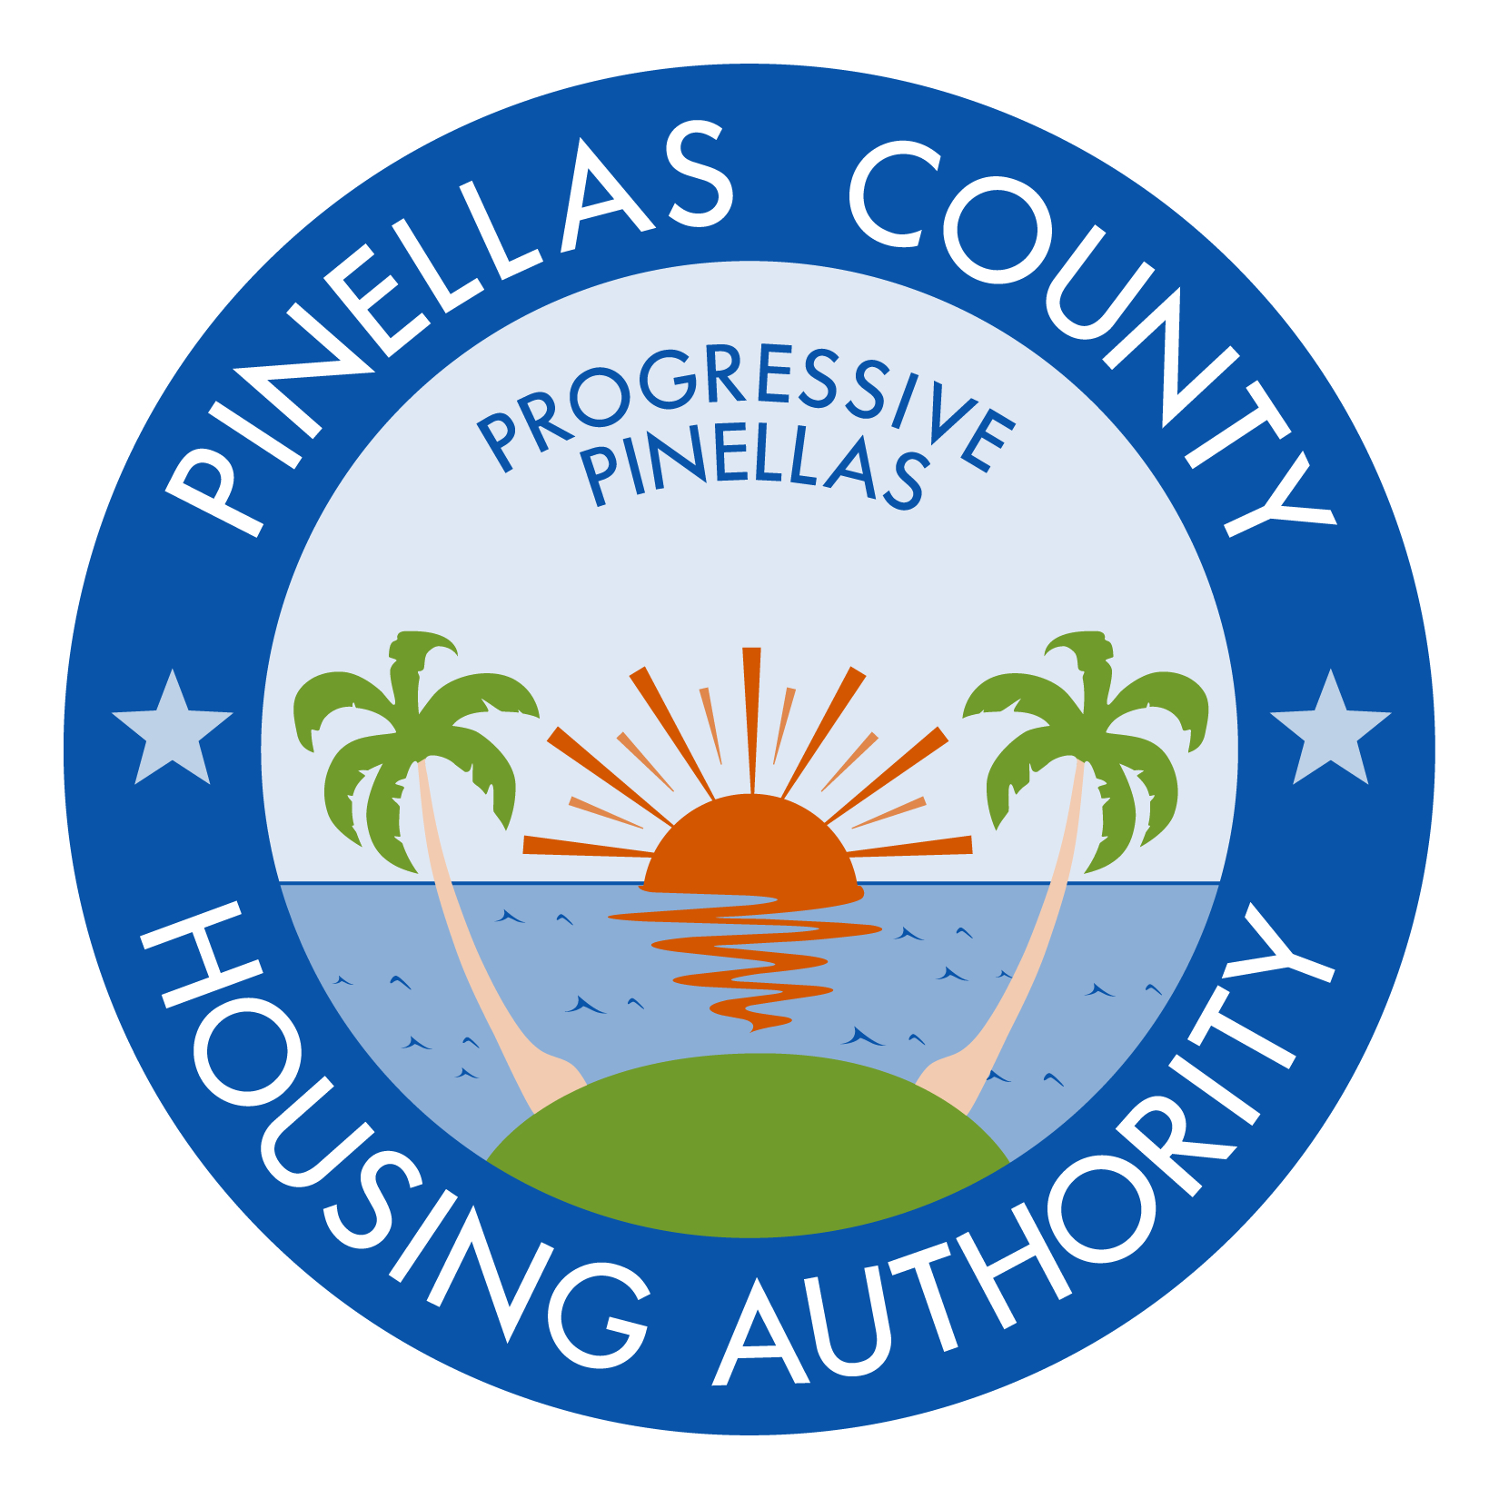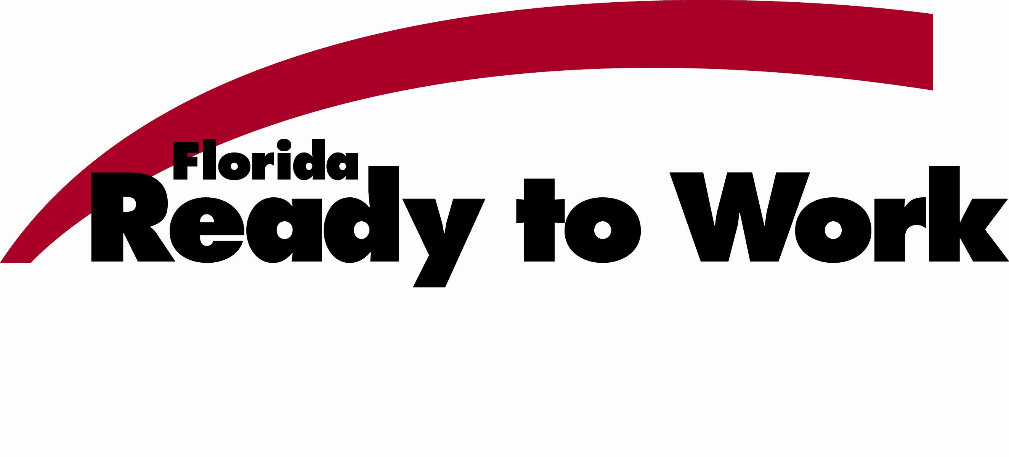

FLORIDA READY TO WORK ENROLLMENT REQUEST FORM

I am interested in enrolling in the Florida Ready to Work program and am willing to provide the required information noted below to get started.

Name ________________________________ _______________________________
First Last

Social Security Number ______-_________-______

Are you the Head of Household? Yes No (please circle one)

If you are not the head of household, provide the name of the head of household.

Name ________________________________ _______________________________
First Last

Address _____________________________________________
Street

_____________________________________________
City State

By providing this information, I am authorizing the Pinellas County Housing Authority to enroll me in the Florida Ready to Work program to earn the Florida Ready to Work Credential.

___________________________________
Print Name

___________________________________ ___________________________________
Signature Date

